Development of software for
Integrated Manuscript, Digitization, Cataloguing & Management System
Contents
1 Introduction 3
2 Technical Considerations 4
3 The Need and Requirements Summary 6
4 The Work Completed 7
4.1 MDR - A database and Enterprise Web Application 7
4.2 A Content Management System(CMS) 11
5 The Work to be Completed 13
5.1 Integrate the CMS with the MDR Application 13
5.2 Improved UI for the MDR Application 13
6 Schedule of Implementation 14
6.1 Technology and System Requirements 14
6.2 Technology and System Requirements - 14
6.3 Project Schedule 14
6.4 Project Effort and Cost 15
6.5 Project Resources - Narasimhan M.G 16
6.6 Required Team Roles & functions 17
6.7 Skill Pre-requisites and options 18

Introduction
Knowledge Management is an process by which wealth or value is generated (intangible or tangible) from intellectual or knowledge based assets.
Why Knowledge Management in the area of Manuscripts?
  - Manuscript is a Knowledge Based Asset of our Nation
  - Lakhs of Manuscripts are available with different stakeholders
  - Enormous amount of knowledge present in these
  - Need to minimize the process - time gap between the possessor of manuscript and the user of knowledge in the manuscript
  - Need a common platform for harnessing, dissemination and application of the knowledge present in these manuscripts.

Technical Considerations

A digitization project includes the “basic processes - creation, storage, and management. There are components to the digitization project:
- Image creation deals with the initial capture or conversion of a document or object into digital form, typically with a scanner. There may then be one or more file or image processing steps applied to the initial image, which may alter, add, or extract data. Processing will include image editing (scaling, compression, sharpening, etc.) and metadata creation.
- File management refers to the organization, storage, and maintenance of images and related metadata.
- Image delivery incorporates the process of getting images to the user and encompasses networks, display devices, and printers.
The tasks needed to address the above components:

- Selecting items
- Recording items going to digitization
- Preparing items for digitization
- Digitization of items
- Recording digitization method and attributes (color and scale reference)
- Naming image file
- Saving image file
- Recording image file location
- Returning items to archival storage
- Recording items returned
- Noting image file creation

Digitization Project Considerations:
- The technology necessary to complete the digitization consists mainly of hardware, software, and networks.
- Protocols and standards, policies and procedures required for workflow, maintenance, security, upgrades, etc.
Considerations that will affect decisions about the technical infrastructure include:
- Quality requirements based on document attributes
  - Assessing document attributes (detail, tone, color)
  - Defining the needs of current and future users
  - Objectively characterizing relevant variables (e.g., size of detail, desired quality, resolving power of system)
  - Correlating variables to one another via formulas
  - Confirming results through testing and evaluation
- User Needs
  - File format and compression used
  - Web browser capabilities
  - Network connections
  - Scaling routines and programs
  - End user computer and display capabilities
- Setting long-term preservation plans like:
  - Retaining the physical reliability of the image files, accompanying metadata, scripts, and programs (e.g., make sure that the storage medium is reliable with back-ups, maintain the necessary hardware and software infrastructure to store and provide access to the collection)
  - Ensuring continued usability of the digital image collection (e.g., maintain an up-to-date user interface, enable users to retrieve and manipulate information to meet their information needs)
  - Maintaining collection security (e.g., implement strategies to control unauthorized alteration to the collection, develop and maintain a rights management program for fee-based services)

The Need and Requirements Summary
The high level requirements and scope of this project includes:

Design, Develop and Deploy an integrated web based multilingual manuscript digitisation and management system whose scope and components includes the following
- Ability to categorize manuscripts. ( A standard coding and categorization system to be evolved)
- High level summary of digitized manuscripts through manuscript data system
- Creation of Search Engine – multilingual search, archiving, executive summary search, key word search and other advanced search options
- Conversion of the edited text version to e- book version
- Other features that could be included in web based tool would be
- Web based collaboration platform through which stakeholders can disseminate knowledge ( discussion forms, discussion about a particular manuscript, news and events about a manuscript, manuscript wiki, manuscript newsletter)

Scope Exclusions : 1) Scanning and digitization software.
2) All hardware necessary for the above like scanning equipment, etc

The Work Completed

MDR - A database and Enterprise Web Application
The Manuscripts Digital Repository(MDR) is a database and a Java Enterprise Edition Web Application has been developed, based on approved use case analysis, database design and standard JEE Model View Controller architecture. It consists of a presentation layer in JSF, standard EJB middle layer, and DAO layer for database access from MySql. It runs on Glassfish Web Server on Ubuntu Linux System. It is similar to a Library Card Index system with The Digital Manuscript being the core of the system. An overview of the functionality is given below.
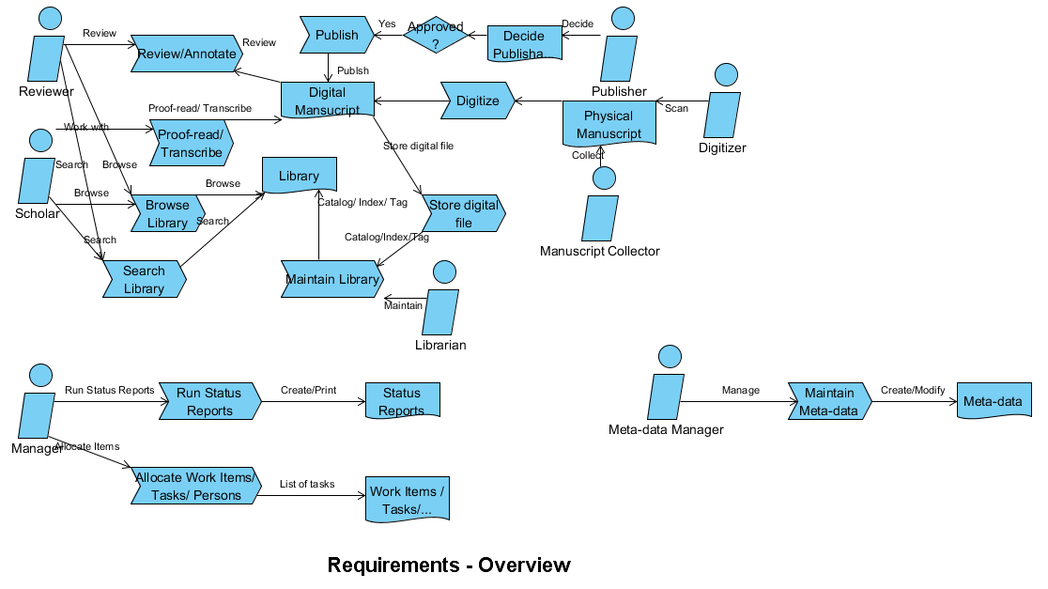

A Manuscript Collector collects Physical Manuscripts and delivers them to a Digitizer. The Digitizer scans and digitizes the Physical Manuscript and Stores an image file in standard formas specified by the National Manuscripts Mission (NMM) as a Digital Manuscript (DM). A Librarian then files, catalogs and indexes the Digital Manuscript into the Library (Manuscript Digital Repository). Scholars can Browse Library, Proof-Read and Transcribe the individual Digital Manuscript. A Reviewer then does a Review/ Annotate/ Approve process for the DM and the Transcript. After approval, the DM is Published in the MDR and available to other stakeholders. Other schlolars, editors and knowledge workers can Search, Browse Library, read, comment on and further annotate the DMs.
A Manager can Allocate Work to scholars, reviewers, publishers ,monitor the status of work, and Monitor Document Status. He/she also manages access permissions and levels to various types of users of the MDR. He/she will need various types of work-flow mechanisms and reports which assist in his/her work.
A Meta-Data manager creates and maintains tags and indexing terms which others can use to tag Digital Manuscripts. This is useful for Search of specific DMs or set of DMs.
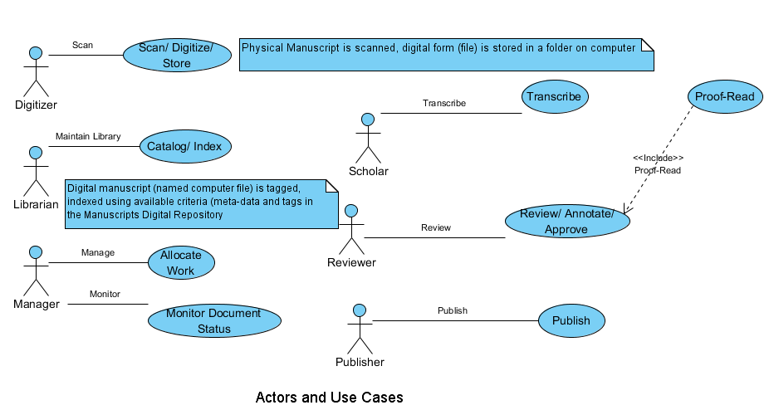
User Type | Use Case
Manuscript Collector | None
Digitizer | Scan and Digitize
Librarian | Catalog and Index
Scholar | Search/ Filter
 | Browse Library
 | View Digital Manuscript (DM)
 | Transcribe DM
 | Proof-read Transcription
Reviewer | Annotate Transcriptions
 | Comment on Transcriptions
 | Approve DM
Publisher | Publish DM
Manager | Allocate work
 | Monitor Status
Meta-data Manager | Create and Maintain Tags

This system has been developed with a very basic User Interface which needs to be made professional and "good-looking".
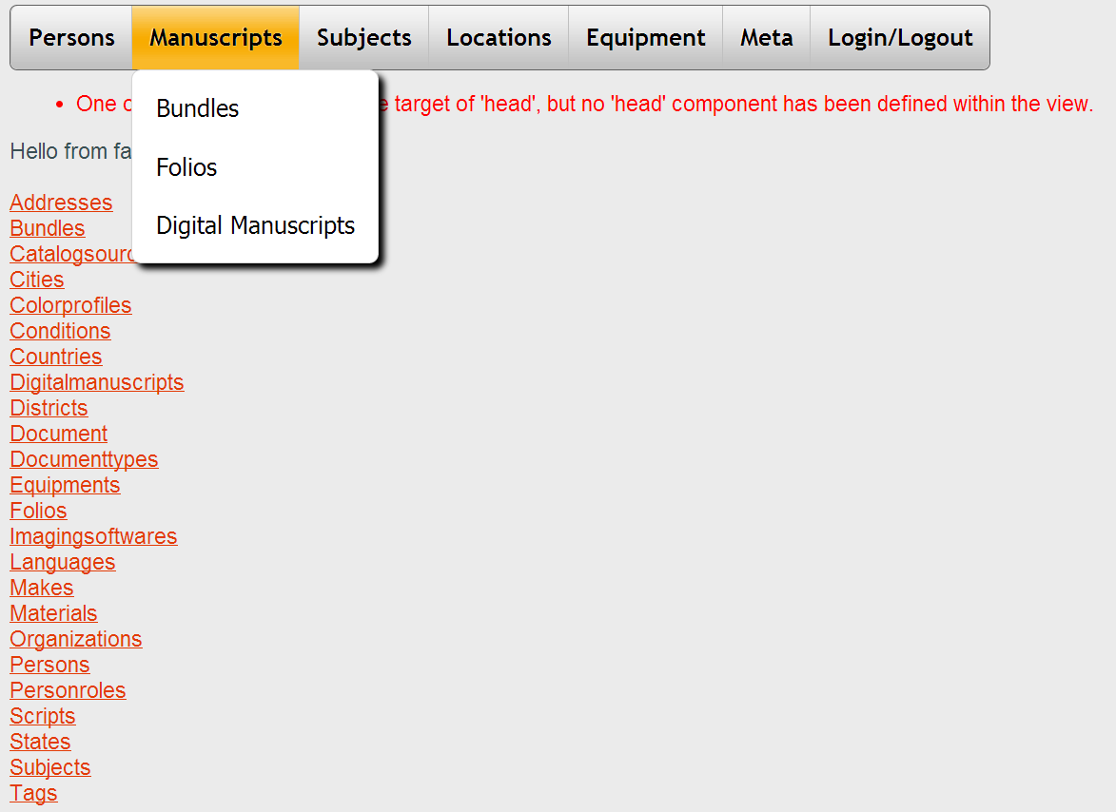

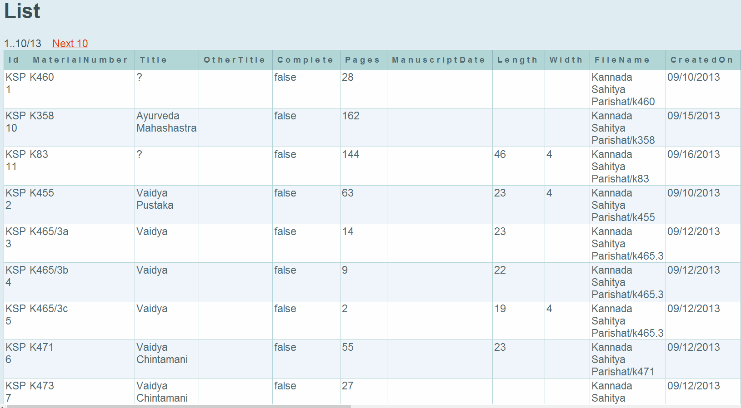
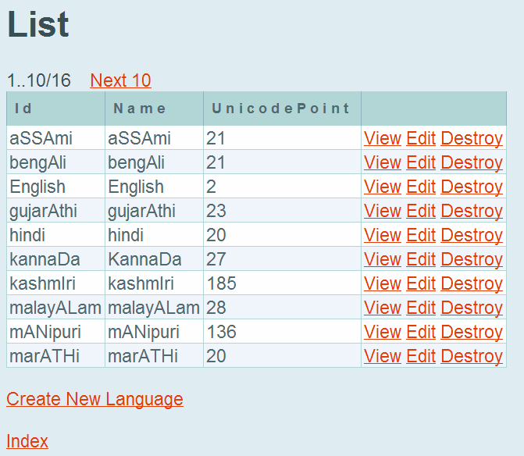
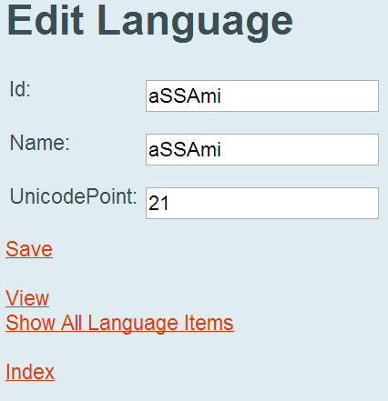

A Content Management System(CMS)
A CMS based on the Alfresco CMS has been installed. This enables digitized JPEG/TIFF image files to be uploaded, shared and annotated.
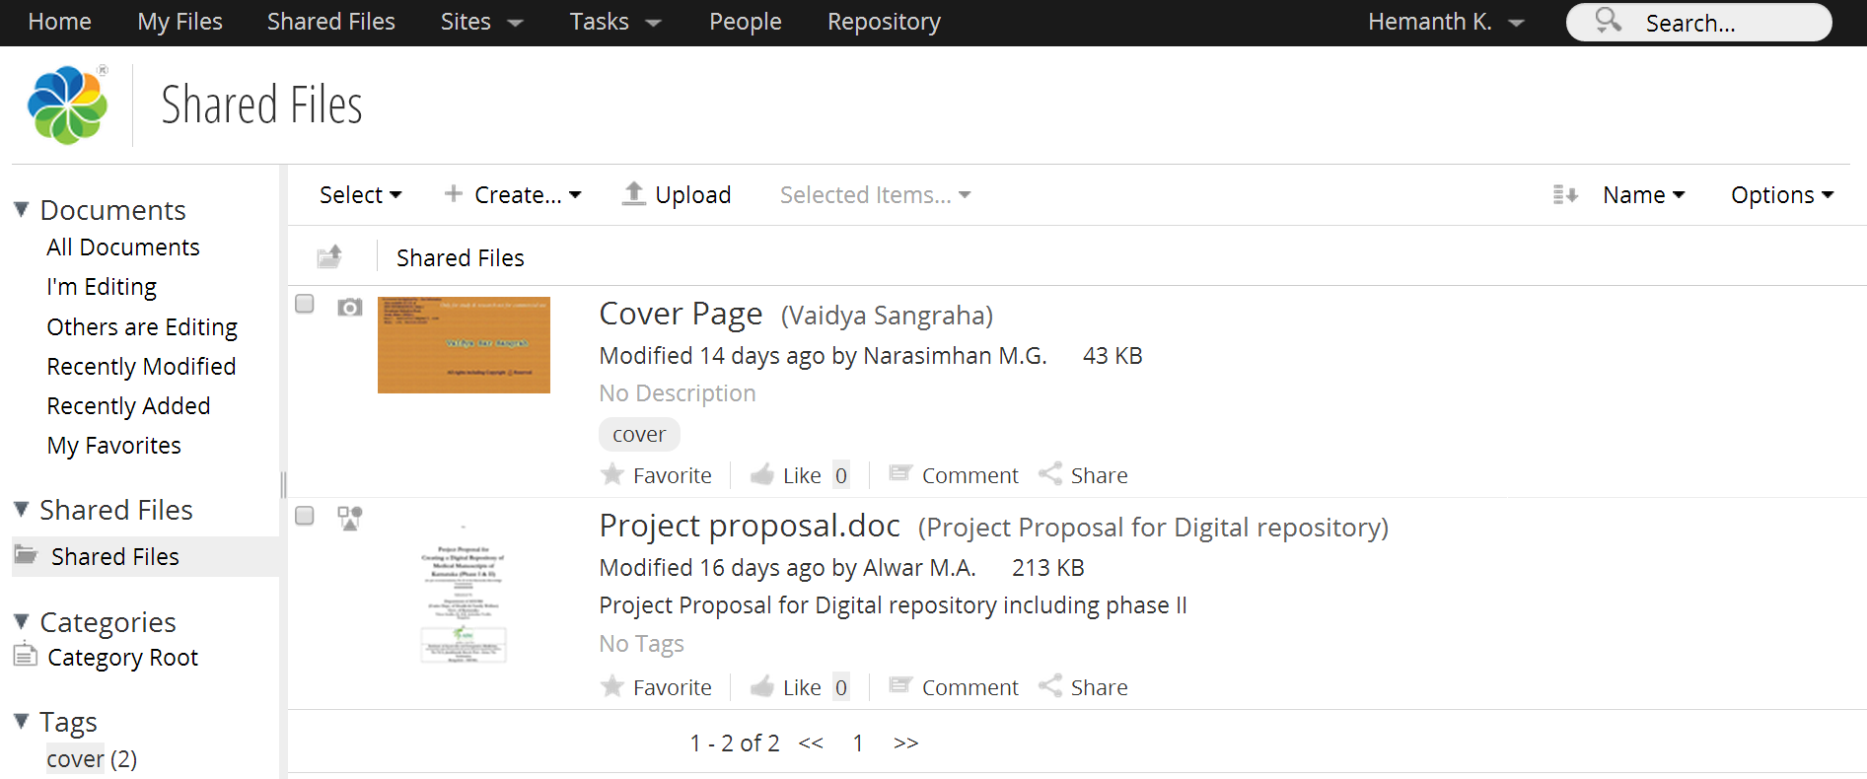

Alfresco allows usres to share files in a comon area. This is being used to upload digital images of manuscripts, transcribe them in MS Word or Indian language editors and circulate them for review by scholars. These scholars are experts in Sanskrit and other classical languages and can decipher and read scripts like Brahmi, Grantha etc.

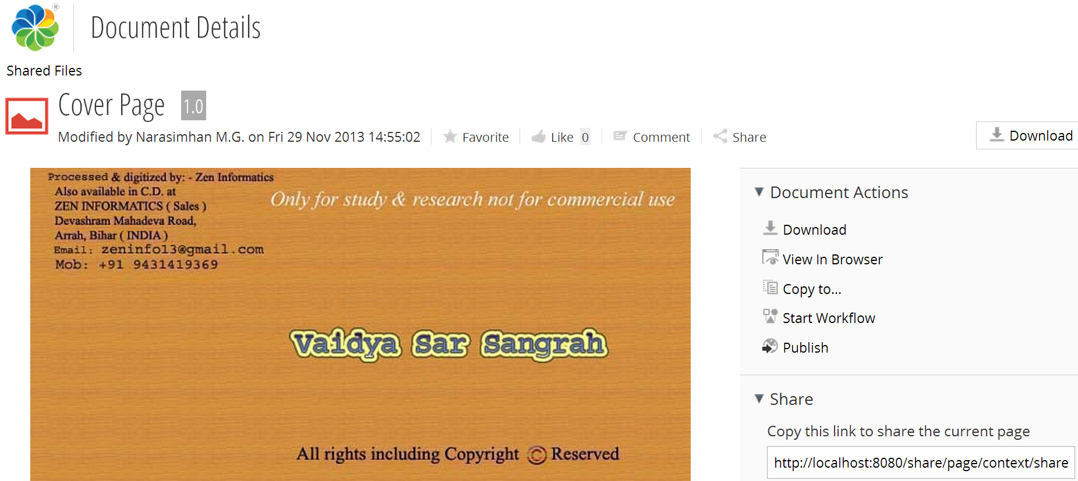

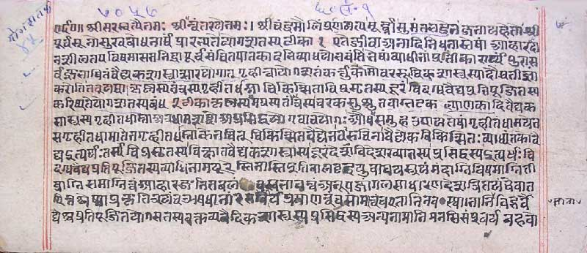

The Work to be Completed

Integrate the CMS with the MDR Application
The 2 systems have to be synchronized with each other. This means
- A basic programmatic communication protocol/path between the MDR and the digital manuscripts on the CMS. This will follow the native API of the selected CMS. The CMS is right now Alfresco, but other CMS systems can also be considered.
- Retrieval of a digital manuscript based on search and record retrieval from the MDR database
- Event notification between the 2 systems so that the MDR has data on the physical location (URL on the CMS) of any digital manuscript, associated annotation files, transcripts, comment files and review files prepared by scholars and experts
- Search based on given key words, tags etc both on the MDR and the CMS
- Workflow and task delegation and managment (activities like transcribe, review, scan, digitize etc). Task volumes, number of digital manuscripts uploaded, trabscribed, reviewded, annotated etc should be available on dashboards to work flow managers.

Improved UI for the MDR Application
- The current UI is quite simple. It needs to be enhanced with dashboards, pleasant look and feel, dynamic screen areas, easy document management, workflow and status reports.

Schedule of Implementation

Technology and System Requirements

Technology and System Requirements -
- Hosting during development phase will be at FRLHT.
- Server for hosting the application and database.

Project Schedule
All the tasks associated with this part of the project will be completed in a period of One year as follows:
ACTIVITY | Start | Duration(days) | Finish
Manuscripts Digital Repository | 16-12-13 | 65 | 18-02-14
Evaluation | 16-12-13 | 30 | 14-01-14
Required Features List | 16-12-13 | 5 | 20-12-13
Workflow | 16-12-13 | 2 | 17-12-13
Document Archiving & indexing | 16-12-13 | 2 | 17-12-13
Categorinzing (Meta-data Mgmt) | 16-12-13 | 2 | 17-12-13
Catalog Management | 16-12-13 | 2 | 17-12-13
Editing & Publishing | 16-12-13 | 2 | 17-12-13
Workflow Management | 16-12-13 | 1 | 16-12-13
Define WF | 16-12-13 | 1 | 16-12-13
Change WF definition | 16-12-13 | 1 | 16-12-13
Maintain WF Items (add/change/remove/assign) | 16-12-13 | 1 | 16-12-13
Track WF items | 16-12-13 | 1 | 16-12-13
Dashboards | 16-12-13 | 1 | 16-12-13
WF Item queues | 16-12-13 | 1 | 16-12-13
WF Item Routing | 16-12-13 | 1 | 16-12-13
Pending items | 16-12-13 | 1 | 16-12-13
Search/Keywords/Tags | 16-12-13 | 3 | 18-12-13
Metrics/Reports | 16-12-13 | 2 | 17-12-13
Available CMS / tools | 16-12-13 | 5 | 20-12-13
Alfresco | 16-12-13 | 5 | 20-12-13
Liferay | 16-12-13 | 5 | 20-12-13
Nuxeo | 16-12-13 | 5 | 20-12-13
Custom-built | 16-12-13 | 5 | 20-12-13
Buy-or-Build analysis | 23-12-13 | 9 | 31-12-13
Costs | 23-12-13 | 2 | 24-12-13
Selected Tools | 25-12-13 | 7 | 31-12-13
Tool Skills and Training | 01-01-14 | 14 | 14-01-14
Content Management Concepts | 01-01-14 | 7 | 07-01-14
Workflow Concepts | 01-01-14 | 7 | 07-01-14
Roles and Permissions | 01-01-14 | 7 | 07-01-14
Document Types | 01-01-14 | 7 | 07-01-14
Content Modeling | 01-01-14 | 7 | 07-01-14
Workflow Design | 01-01-14 | 7 | 07-01-14
Programming (Java) with selected CMS tools | 01-01-14 | 14 | 14-01-14
System Design/ Build/ Integration | 15-01-14 | 28 | 11-02-14
Module coding/unit testing | 15-01-14 | 14 | 28-01-14
Queries/Reports | 15-01-14 | 7 | 21-01-14
Search/Keywords/Tags | 15-01-14 | 14 | 28-01-14
Well-designed User Interface | 15-01-14 | 14 | 28-01-14
MDR Application - Integration with CMS | 15-01-14 | 28 | 11-02-14
MDR Application to CMS (Alfresco) Basic Communication | 15-01-14 | 14 | 28-01-14
Status updates between CMS and MDR App. | 29-01-14 | 14 | 11-02-14
Events notifications between CMS and MDR App. | 29-01-14 | 14 | 11-02-14
System Tests | 15-01-14 | 9 | 23-01-14
Test Summaries and Reports | 24-01-14 | 4 | 27-01-14
Release Approval | 27-01-14 | 1 | 27-01-14
User Acceptance | 12-02-14 | 6 | 17-02-14
UAT Runs | 12-02-14 | 2 | 13-02-14
UAT Reports | 14-02-14 | 1 | 14-02-14
UAT Review | 17-02-14 | 1 | 17-02-14
UAT approval | 17-02-14 | 1 | 17-02-14
Deployment | 18-02-14 | 1 | 18-02-14
Implementation | 18-02-14 | 1 | 18-02-14
Project Closure Report | 19-02-14 | 1 | 19-02-14
Closure Report Approval | 19-02-14 | 1 | 19-02-14

Project Effort and Cost
Resource | Effort(days)
Project Manager | 5
Selected Tools | `
Release Approval | 1
UAT Review | 1
UAT approval | 1
Project Closure Report | 1
Closure Report Approval | 1
Management | 135
System Analyst | 44
Workflow | 2
Costs | 2
Content Management Concepts | 5
Workflow Concepts | 5
Document Types | 5
Roles and Permissions | 5
Content Modeling | 5
Workflow Design | 5
Programming (Java) with selected CMS tools | 10
Database Architect | 10
Content Management Concepts | 5
Content Modeling | 5
Test Manager | 3
Test Summaries and Reports | 2
UAT Reports | 1
Senior Developer | 48
Workflow | 2
Workflow Management | 1
Content Management Concepts | 5
Workflow Concepts | 5
Document Types | 5
Roles and Permissions | 5
Content Modeling | 5
Workflow Design | 5
Programming (Java) with selected CMS tools | 10
Available CMS / tools | 5
Developer 1 | 16
Workflow Management | 5
Implementation | 1
Queries/Reports | 5
Available CMS / tools | 5
Developer 2 | 1
Search/Keywords/Tags | 1
Tester 1 | 7
System Tests | 7

Project Resources - Narasimhan M.G

He is From IIT Madras Mtech(C.S) in 1978. He has done many corporate systems analysis/design/build etc. Sectors he has worked in are Oil companies, Insurance, Offshore Engineering, Financial systems, Corporate Business Systems, Govt. organizations etc. I've worked in Scandinavia, England, US and Africa.

Technically he has worked on IBM Mainframes, Unix, PCs/Servers. Languages and Systems known are Java/J2EE, VB, , Python, C++, PHP, Cobol, Fortran, Unix Shell, DB2, MySQL, Eclipse, Netbeans, MS Visual Studio etc. He has done a lot of software project management using several methodologies.

He has also designed and conducted training on JBoss, C, Java, and authored Computer-based Training courses using a platform called Moodle.

He knows Database design, System Architecture and Design, Object Oriented Analysis and Design, UML diagams etc.

He has worked earlier on Sanskrit based software development, project planning and reporting at Academy of Sanskrit research.

Required Team Roles & functions
Resource | Tasks | Person
Project Manager | Release Approval | Narasimhan M.G.
 | Project Closure Report
 | Review by project board
 | Management
System Analyst | Define Workflow
 | Change Workflow Definition
 | Maintain Workflow Items (add/change/remove/assign)
 | Track Workflow items
 | Workflow Item queues
 | Workflow Item Routing
 | Pending items
 | Metrics/Reports
 | Search Engine (multi-lingual)
 | Selected Tools
System Architect | Define Workflow
 | Change Workflow Definition
 | Maintain Workflow Items (add/change/remove/assign)
 | Track Workflow items
 | Workflow Item queues
 | Workflow Item Routing
 | Pending items
 | Metrics/Reports
 | Search Engine (multi-lingual)
 | Class Design (OO)
 | UML Diagrams
 | Tool Integration Plan
Database Architect | Database Design
Test Manager | Test Summaries and Reports
 | Acceptance Test Reports
 | User Acceptance Test Plan
Senior Developer | Scanning, Digitization & Storage | ?
 | Document Archiving & indexing
 | Categorizing (Meta-data mgmt)
 | Catalog Management
 | Document Archiving & indexing
 | Categorizing (Meta-data mgmt)
 | Catalog Management
 | Editing & Publishing
 | Multi-lingual Scripts
Developers(2) | Scanning, Digitization & Storage | ?
 | Define Workflow
 | Change Workflow Definition
 | Maintain Workflow Items (add/change/remove/assign)
 | Track Workflow items
 | Metrics/Reports
 | Search Engine (multi-lingual)
 | Help Desk
 | System Tests
Scolars(2) | Scolar 1
(Sanskrit/Manuscripts) | Acceptance Test Reports
 | Acceptance Test Runs

Skill Pre-requisites and options
The Project Manager will be heading a team with the required expertise in JEE database programming, CMS Java programming experience/expertise and developers, testers, anlyst/architect who will oversee and monitor the work done with regular meetings and status reporting.
**********

